|  |  |
| --- | --- |
| *school-learn-study-hat-graduate-512.png* | ***Study*** |

Read Chapter 5, section 5.1, 5.3, 5.5, 5.6, 5.7 and 5.10 of “How to Think Like a Computer Scientist: Learning with Python 3”:

<http://www.ict.ru.ac.za/Resources/cspw/thinkcspy3/thinkcspy3.pdf>

And then answer the following questions:

1. What is Boolean? Write down 3 different expression that results a Boolean type (i.e. 5 == 6)

***Answer:***

- A Boolean value is either true or false.

- 3 different example:

>>> 5 == (3 + 2)

True

>>> n = "Khau"

>>> n + "Tu" == "Khau Tu"

False

>>> n + "Tu" == "KhauTu"

True

>>> "KhauTu" != "TuKhau"

True

1. What is a flow chart? Draw flow chart for the following code snippet: (you can draw on a paper, take a picture of it)

if name == “Huy be":

print(“Hand some")

elif name == “Huy big":

even\_more\_handsome = True

else:

webbrowser.open(“<https://www.youtube.com/watch?v=04854XqcfCY>”)

***Answer:***

A flowchart is a visual representation of the sequence of steps and decisions needed to perform a process.

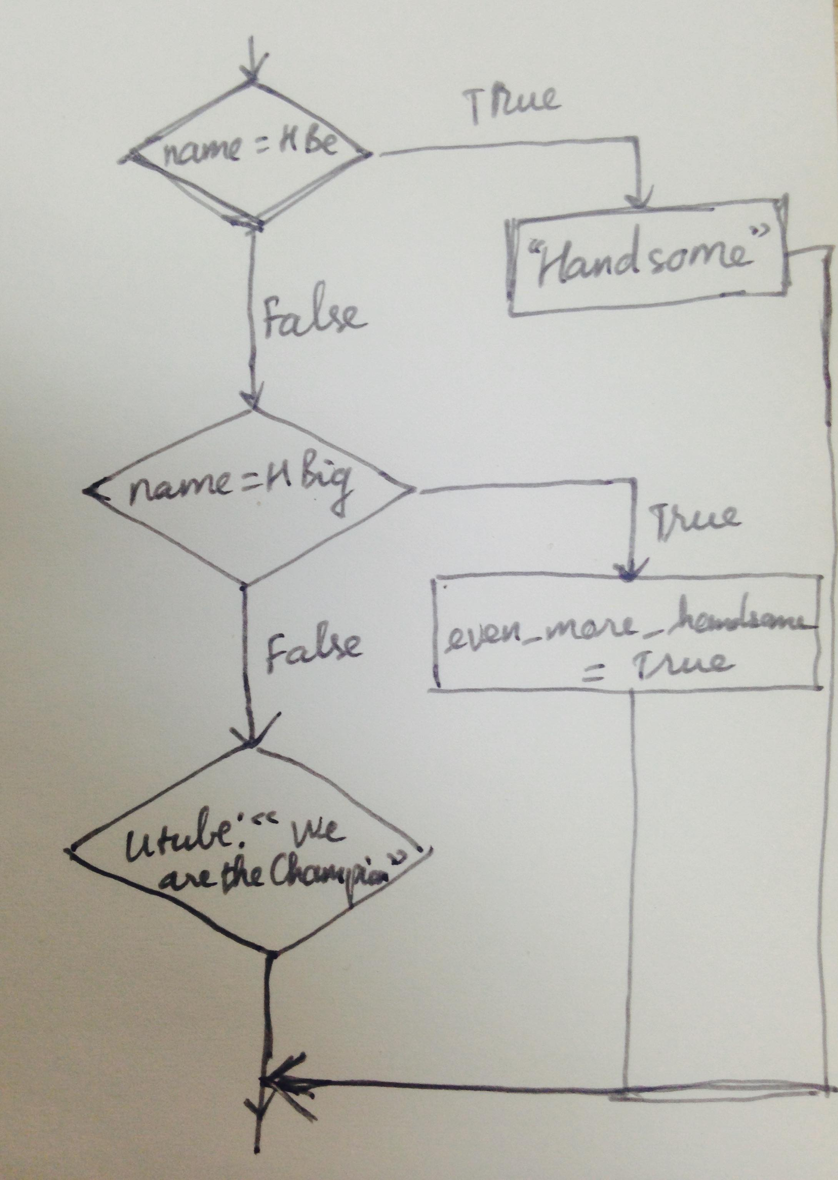

1. What is nested conditionals? Write a piece of code that uses nested conditionals

***Answer:***

Nested conditionals statements means that you can use one if or else if statement inside another if or else if statement(s).

Example:

|  |  |
| --- | --- |
| *http://www.bestappsforkids.com/wp-content/uploads/2012/04/save-turtle.png* | ***Turtle exercises*** |

Using turtle to draw the following shapes:

|  |  |
| --- | --- |
| Screen Shot 2015-12-25 at 04.41.55.png | 2.  Hi-CBUEkYGb-DOPBqc1p-_os3fG83P3OxHLgEhilkO4 |
|  |  |

|  |  |
| --- | --- |
| *6iporAnbT.jpg* | ***Serious exercises*** |

1. Write a program that asks user their height (cm) and weight (kg), and then calculate their BMI (Body Mass Index):

BMI = mass (kg) / (height(m) x height(m) )

Note: you must do the conversion from cm to m before calculation

Then based on the BMI, tell them that they are:

* Severely underweight if BMI < 16
* Underweight if BMI is between 16 and 18.5
* Normal if BMI is between 18.5 and 25
* Overweight if BMI is between 25 and 30
* Obese if BMI is more than 30

1. Write a program that
   1. Asks users enter a number and then calculates factorial of n: (1 \* 2 \* 3 \*... \*n)
2. Study how to print without moving to a new line

Each time we call print(...) to print out something, python will automatically move to a new line, for example, the following snippet:

print("Hello")

print(",my name")

print("is B-max")

will result:

Hello

,my name

is B-max

Your task: Try to search and learn how to print without moving to new line,:

print("Hello", ...)

print(",my name", ...)

print("is B-max", ...)

# "..." is the piece of code you would add

so that the result would be

Hello,my name is B-max

1. Print out the following patterns, remember that the number of columns and rows can be changed later, so try to write programs that can scale
   1. 40 x 1 stars (could be 20 x 1 or 50 x 1 or whatever)

\* \* \* \* \* \* \* \* \* \* \* \* \* \* \* \* \* \* \* \* \* \* \* \* \* \* \* \* \* \* \* \* \* \* \* \* \* \* \* \*

* 1. 40 stars and xs (could be 20 x 1 or 50 x 1 or whatever)

x \* x \* x \* x \* x \* x \* x \* x \* x \* x \* x \* x \* x \* x \* x \* x \* x \* x \* x \* x \*

* 1. You can use **print()**, (yes, print with **nothing inside the parentheses ()**) to move to new line, try it
  2. 10 x 10 stars (it should also work with 20 x 30 stars or any size given to the program)

\* \* \* \* \* \* \* \* \* \*

\* \* \* \* \* \* \* \* \* \*

\* \* \* \* \* \* \* \* \* \*

\* \* \* \* \* \* \* \* \* \*

\* \* \* \* \* \* \* \* \* \*

\* \* \* \* \* \* \* \* \* \*

\* \* \* \* \* \* \* \* \* \*

\* \* \* \* \* \* \* \* \* \*

\* \* \* \* \* \* \* \* \* \*

\* \* \* \* \* \* \* \* \* \*

* 1. 10 x 10 stars and x’s (it should also work with 20 x 30 stars or any size given to the program)

x \* x \* x \* x \* x \*

\* x \* x \* x \* x \* x

x \* x \* x \* x \* x \*

\* x \* x \* x \* x \* x

x \* x \* x \* x \* x \*

\* x \* x \* x \* x \* x

x \* x \* x \* x \* x \*

\* x \* x \* x \* x \* x

x \* x \* x \* x \* x \*

\* x \* x \* x \* x \* x

|  |  |
| --- | --- |
| system_config_boot.png | ***Tools preparation*** |

Watch the homework submission tutorial